**Dropbox**: One of the core features of cloud computing is availability anywhere, at any time, and from any Internet-connected device.

The most popular solution for online document storage is Dropbox, an online application that allows users to synchronize any file across any platform and any device in a seamless manner. Dropbox provides users with a free amount of storage that is accessible through the abstraction of a folder. Users can either access their Dropbox folder through a browser or by downloading and installing a Dropbox client, which provides access to the online storage by means of a special folder. All the modifications into this folder are silently synched so that changes are notified to all the local instances of the Dropbox folder across all the devices. The key advantage of Dropbox is its availability on different platforms (Windows, Mac, Linux, and mobile) and the capability to work seamlessly and transparently across all of them.

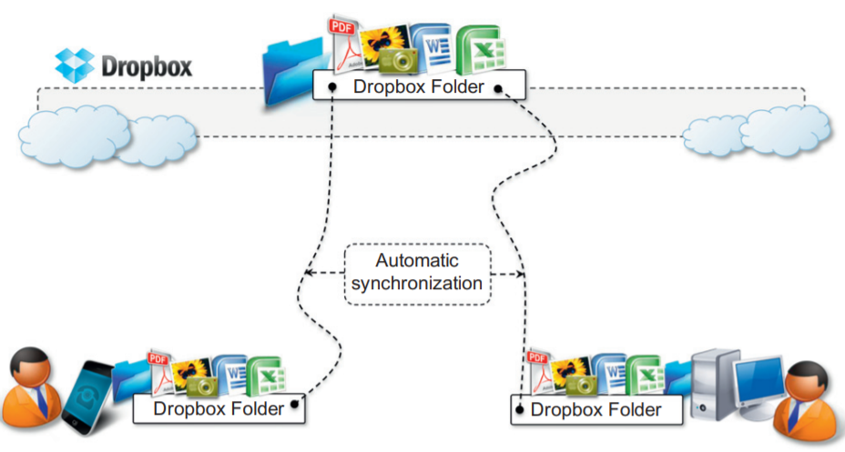

**iCloud:** A cloud-based document-sharing application provided by Apple to synchronize iOS-based devices in a completely transparent manner. Unlike Dropbox, which provides synchronization through the abstraction of a local folder, iCloud has been designed to be completely transparent once it has been set up. Documents, photos, and videos are automatically synched as changes are made, without any explicit operation. This allows the system to efficiently automate common operations without any human intervention: taking a picture with your iPhone and having it automatically available in iPhoto on your Mac at home; editing a document on the iMac at home and having the changes updated in your iPad. Unfortunately, this capability is limited to iOS devices.